Logic Lab Car Activity

[http://www.neuroproductions.be/logic-lab/](http://www.google.com/url?q=http%3A%2F%2Fwww.neuroproductions.be%2Flogic-lab%2F&sa=D&sntz=1&usg=AFQjCNFq5w9Lyd5-Fjw9J9FkIeDKA863bA)

Note: This is a puzzle for you to try to solve.  Your job is to experiment by adding logic gates, wire splitters, etc. until you succeed on hitting all the criteria of the challenge.  You will only get marked on the completion of Challenge #1.  The remaining challenges, however are required for you to attempt.

**Challenge #1:  Gas and Brake**

Setup your screen such as the following image.  You will need 4 propellers (your wheels), 2 switches and 1 or 2 splitters.

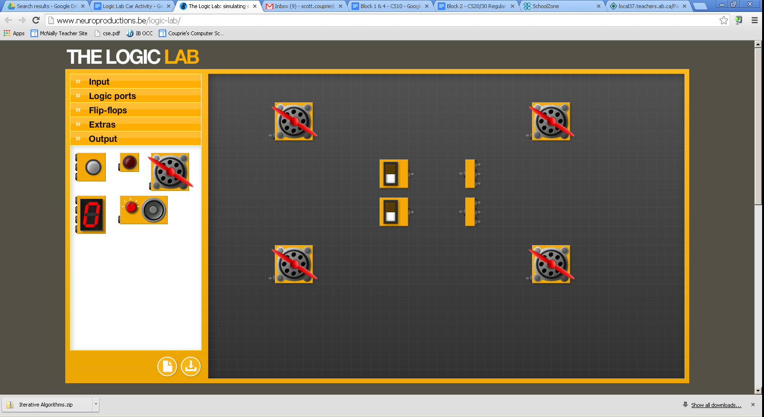

**Assume the top ‘pedal’ is the brake. The bottom is the gas.**

Program the car with the following features:

* when the gas pedal is pressed (bottom switch), all four wheels start to spin (unless the brake is also pressed)
* when the brake is pressed, all four wheels will be stopped
* when the brake and gas is pressed, the engine should just ‘rev’ (in other words, all four wheels will be stopped)

**Challenge #2: Turning**

Building off your existing car, add 2 buttons (to act as the turn switches), 2 lights and a power pulser (plus possibly a splitter for the pulser).

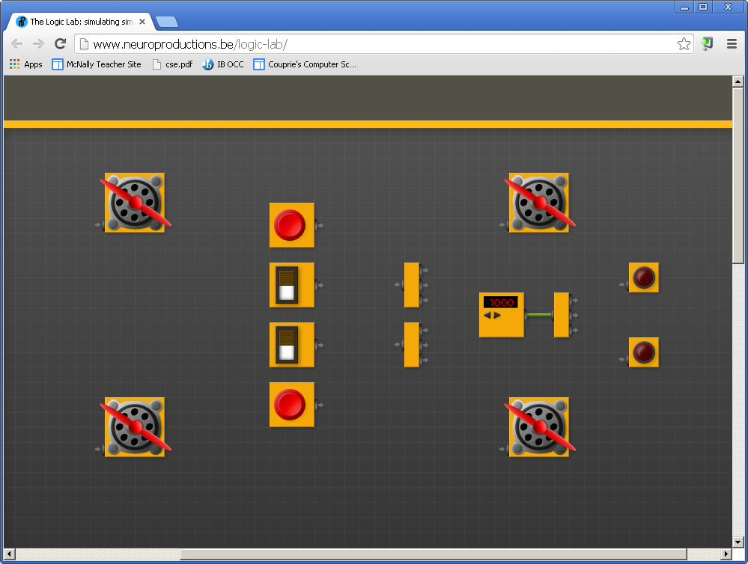

Turning will be indicated by having only 2 of the wheels spinning (like a tank) and the appropriate light being on or flashing. Turning left will mean the top two wheels will be stopped. Turning right will mean the bottom two wheels will be stopped.

Then, program the car with the following features:

* when the gas pedal is pressed AND the right turn signal is on, the car will turn right (bottom wheels off, lower light flashing)
* when the gas pedal is pressed AND the left turn signal is on, the car will turn left
* if the gas pedal is not pressed, the turn signals will not do anything
* for this scenario, you do NOT need to worry about the cases where both signals are pressed or when both the brake and gas pedals are pressed

**Extra challenges:**

Here are some fun things to try if you have time:

* add brake lights
* add a bumper that will turn off the engine in the event of a crash
* add a speedometer. Use multiple switches to represent how far down you are pressing the gas pedal and then wire in the counter to show your speed.
* add whatever else you can think of